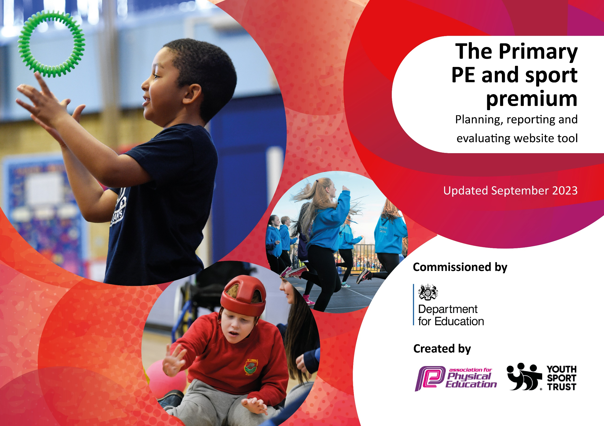

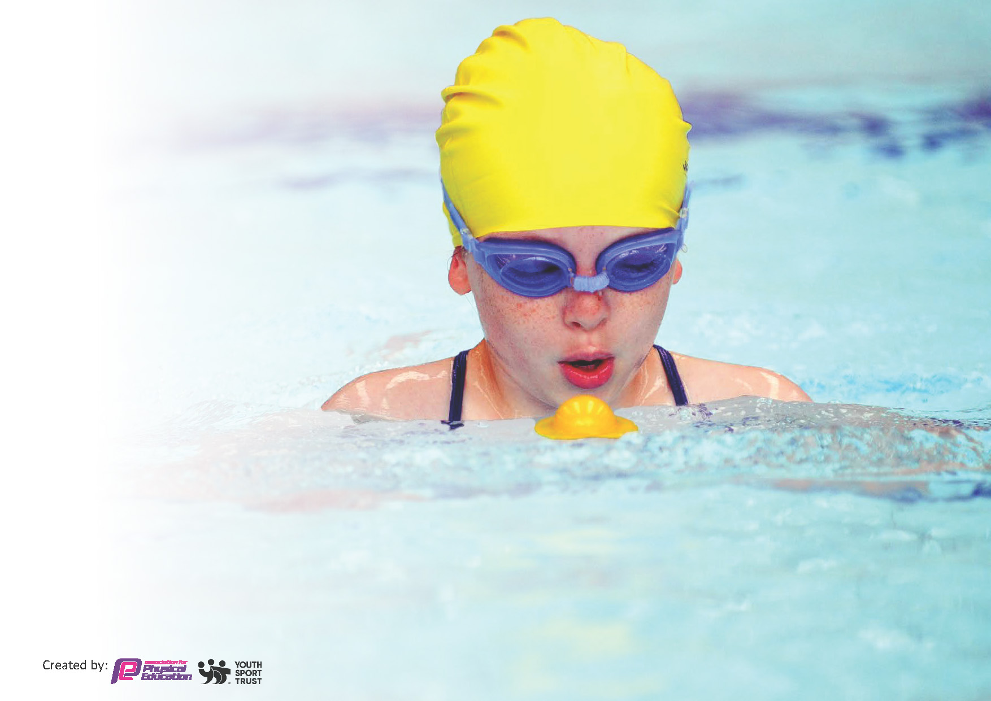
This template can be used for multiple purposes:
by:
- It enables schools to effectively plan their use of the Primary PE and sport premium
- It helps schools to meet the requirements (as set out in guidance) to publish information on their Primary PE and sport premium
- It will be an effective document to support Ofsted inspections enabling schools to evidence progress in Physical Education (PE) and evidence swimming attainment, which forms part of the PE National Curriculum. We would recommend schools consider
the Intent, Implementation and Impact of any spend, as examined within the Education Inspection Framework.

It is important that your grant is used effectively and based on school need.

Schools must use the funding to make additional and sustainable
improvements to the quality of the PE, School Sport and Physical Activity (PESSPA)
they offer. This means that you should use the Primary PE and sport premium to:

- Build capacity and capability within the school to ensure that improvements made now will benefit pupils joining the school in future years
- Develop or add to the PESSPA activities that your school already offers.

The Primary PE and sport premium should not be used to fund capital spend projects; the school’s core budget should fund these. Further detail on capital expenditure can be found in the updated Primary PE and sport premium guidance.

The Primary PE and sport premium guidance, outlines 5 key priorities that funding should be used towards. It is not

necessary that spending has to meet all the key priorities, you should select the priorities that you aim to use any funding towards.

Although completing this template is not a requirement for schools, schools are required to publish details of how they spend this funding. Schools must also outline what the impact this funding has had on pupils’ PE and sport participation and attainment and how any spending will be sustainable in the future. All funding must be spent by 31st July 2024.

The Department for Education has worked closely with the Association for Physical Education (afPE) and the Youth Sport Trust (YST) to develop this template and encourages schools to use it. This template is an effective way of meeting the reporting requirements of the Primary PE and sport premium.
Review of last year’s spend and key achievements (2022/2023)

We recommend you start by reflecting on the impact of current provision and reviewing your previous spend.

Activity/Action | Impact | Comments
To raise the standard of PE taught throughout school.  To increase opportunities for children to participate in competitive sports.  To encourage active play during break and lunch times and after school.  Looking at improving the Early Years and Year 1 outdoor provision to encourage more physical exercise all year round | Professionals to work with ECT’s and other staff to improve subject knowledge and encourage skills and knowledge progression.  To participate in lots of sporting events in the locality, in the Horsham area and nationally (if applicable)  Children are encouraged to be active at playtimes with more PE equipment and organised areas for play. Clubs are supported with the right resources so that all children can participate.  Children to be able to use the allocated area all year round to build big constructions, ride bicycles and be physical active in their play. | We had £18,790 in our Sports Premium Grant this year.  I moves and CPD support £2152.00  Association for PE subscription £115  Competitions £340  Resources £280  £15,810 for the area to allow all children access to this for physical activity.

Key priorities and Planning
This planning template will allow schools to accurately plan their spending.

Action – what are you planning to do | Who does this action impact? | Key indicator to meet | Impacts and how sustainability will be achieved? | Cost linked to the action
Encourage the children to be more active in their lunch and break times with a new trim trail – designed and implemented for the children to use and have increased exercise. Purchase resources to support the playtimes, new castle play facility. . | Lunchtime supervisors / teaching staff and all children across the school | Key indicator 2 -The engagement of all pupils in regular physical activity – the Chief Medical Officer guidelines recommend that all children and young people aged 5 to 18 engage in at least 60 minutes of physical activity per day, of which 30 minutes should be in school. | More pupils meeting their daily physical activity goal, more pupils encouraged to take part in PE and Sport Activities. | £5000 towards the overall cost of the new play castle structure.

CPD for teachers regarding Gymnastics and swimming. | All teachers to receive gymnastics professional development to ensure skills and knowledge are pitched at the right level for each year group.  All teachers to receive swimming training. | Key Indicator 1: Increased confidence, knowledge, and skills of all staff in teaching PE and sport.  Key indicator 5: Increased participation in competitive sport. | Primary teachers more confident to deliver effective PE supporting pupils to undertake extra activities inside and outside of school, including teaching water safety and swimming and as a result improved % of pupil’s attainment in PE. | £2500 for 7 teachers to undertake CPD.
To increase opportunities for children to participate in competitive sports | PE coordinator attends termly meetings with each locality to ensure that the school are participating. Cost of tournament entries to be taken in to consideration. | Key indicator 5: Increased participation in competitive sport.

Key achievements 2023-2024
This template will be completed at the end of the academic year and will showcase the key achievements schools have made with their Primary PE and sport premium spending.

Activity/Action | Impact | Comments

Swimming Data
Meeting National Curriculum requirements for swimming and water safety.
Priority should always be given to ensuring that pupils can perform safe self-rescue even if they do not fully meet the first two requirements of the National Curriculum programme of study

Question | Stats: | Further context  Relative to local challenges
What percentage of your current Year 6 cohort can swim competently, confidently and proficiently over a distance of at least 25 metres? | 87% | 87% can achieve 25 metres.  13% have joined our school recently and are still working towards the 25 metres.
What percentage of your current Year 6 cohort can use a range of strokes effectively [for example, front crawl, backstroke, and breaststroke]? | 87% | As above

What percentage of your current Year 6 cohort are able to perform safe self-rescue in different water-based situations? | 87% | As above
If your schools swimming data is below national expectation, you can choose to use the Primary PE and sport premium to provide additional top-up sessions for those pupils that did not meet National Curriculum  requirements after the completion of core lessons. Have you done this? | Yes | We provide additional swimming sessions for those who are not swimming 25 metres.
Have you provided CPD to improve the knowledge and confidence of staff to be able to teach swimming and water safety? | Yes | We will continue to offer CPD opportunities for swimming.

Signed off by:

Head Teacher: | Samantha Copus
Subject Leader or the individual responsible for the Primary PE and sport premium: | Samantha Copus/Rachel Gowland
Governor: | Sharon Ansell
Date: | 30.04.24

