SWIMMING AWARDS AT ST MARY’S

LEVEL 1  Mermaid/Merman  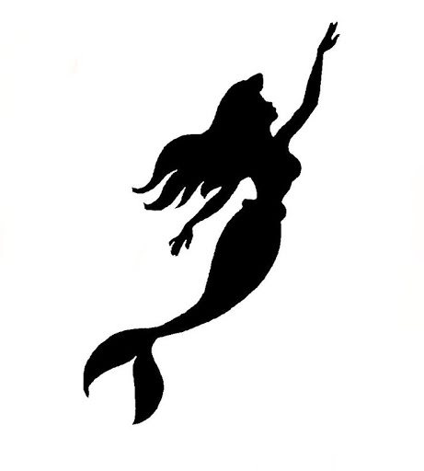  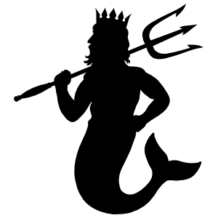 | - Answer 2 water safety questions  - Enter the pool safely, steps, ramp, swivel  - Move 3 meters in the water by walking, jumping hopping or holding side  - Jump up and down in the water, holding the side if required  - Using aids perform an alternating leg action across the pool  - Blow bubbles in the water  - Float with support and return to a standing position  - Exit the pool safely and unassisted
LEVEL 2  Turtle  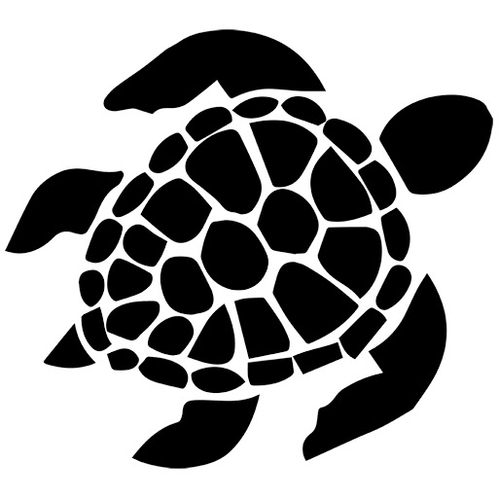 | - Answer 2 water safety questions  - Enter the pool safely, steps, ramp, swivel  - Scoop water with hands and wash face  - Use a woggle to swim front paddle and back paddle for 5 meters  - Push and glide on front and back  - Using aids perform a treading water action with legs  - Using a woggle, rotate from a back float to a front float and return to a back float  - Swim 2 meters front paddle and back paddle unaided
LEVEL 3  Seahorse  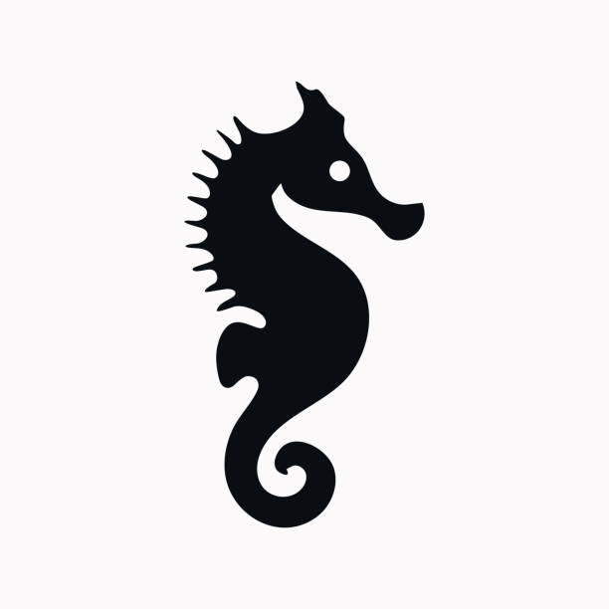 | - Swim 5m on front, roll and swim 5m on back without aids  - Perform 10m of kicking legs on front with aids, whilst blowing bubbles  - Attempt breaststoke legs on back with aids  - Whilst standing attempt front crawl arms  - Whilst standing attempt back crawl arms  - Perform a star float on front or back and hold for 5 seconds  - Jump in with assistance if required  - Perform a reach rescue
LEVEL 4  Goldfish  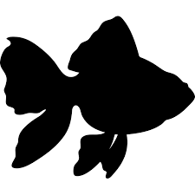 | - Jump in, swim 5m on front and turn onto back, swim back to point of entry (no aids)  - Swim 10m front crawl attempting side breathing  - Swim 10m back crawl  - Tread water for 10 seconds  - Submerge and collect a toy from the pool floor  - Swim 5m breaststroke (aids may be used)  - Perform dolphin leg action  - Perform a mushroom float for 3 seconds
LEVEL 5  Octopus  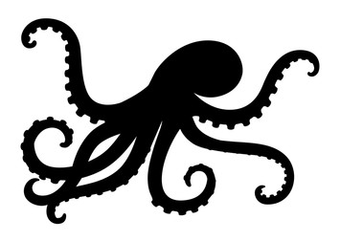 | - Swim 15m front crawl  - Swim 15m back crawl  - Swim 10m breaststroke  - Scull head first or feet first for 5m  - Attempt butterfly arms  - Perform a head or feet first surface dive  - Swim 25m of learners stroke, without aids  - Jump in, tread water for 20 seconds, swim 5m, turn around and swim back to point of entry and climb out
LEVEL 6  Dolphin  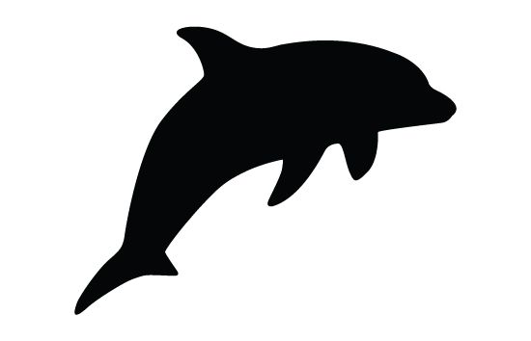 | - Swim 25m front crawl  - Swim 25m back crawl  - Swim 15m breaststroke  - Perform a forward or backward somersault  - Jump in, tread water for 45 seconds, swim back to point of entry and exit  - Swim 5m butterfly  - Perform the HELP position  - Perform a straddle entry into the pool
LEVEL 7  Shark  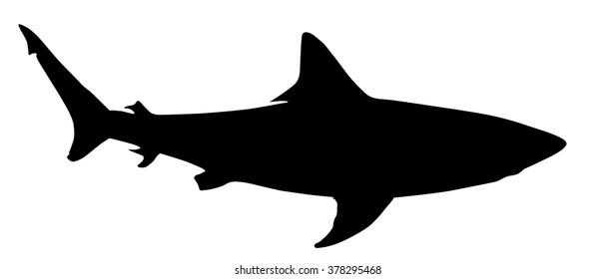 | - Swim 50m front crawl  - Swim 50m back crawl  - Swim 25m breaststroke  - Swim 75m continuously  - Tread water for 1 minute  - Swim 10m butterfly  - Perform a throwing rescue  - Swim 25m in shorts and t-shirt
LEVEL 8  Whale   | - Scull head first and feet first 10m  - Enter the water with a straddle entry, swim 25m in shorts and t-shirt, tread water for 1minute waving one arm, surface dive, swim 5m underwater, surface and remove clothing  - Perform the Huddle position  - Throw a rope 5m to a conscious casualty  - Swim an individual medley incorporating the transition procedure at the end of each stroke  - Perform an accompanied rescue  - Swim 25m Old English backstroke  - Swim 5m of a recognised front stroke, perform a feet first surface dive, tuck and swim 5m underwater

